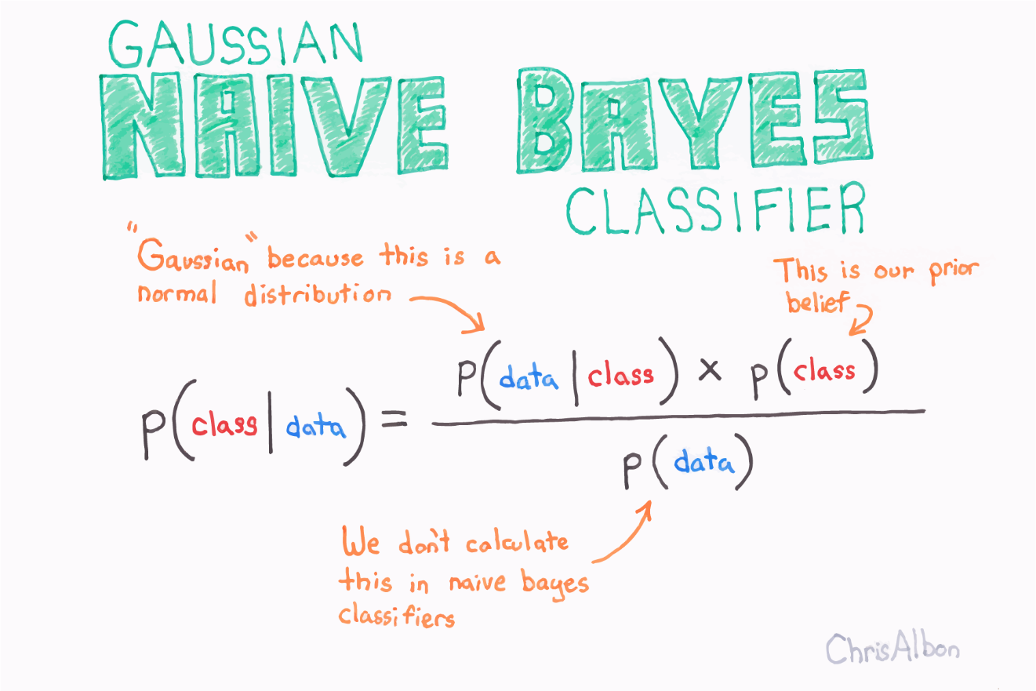

Naïve Bayes Classification

Part C

03717357 | COMP6930 | 24-04-18

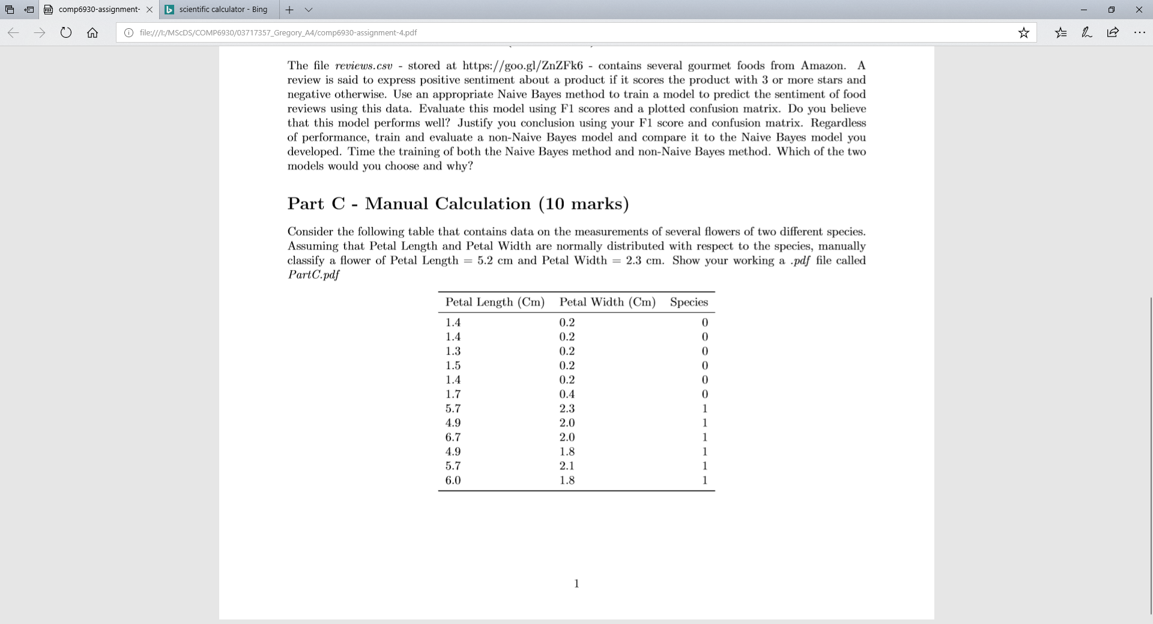

Let’s Calculate the Priors.

$$P\left(species=0\right)=P\left(species=1\right)=\frac{6}{12}=0.5$$

Now Petal Width and Petal Length are distributed normally with respect to Species.

Let’s use the estimates of the mean and variance to describe these normal distributions.

$$μ_{petal length | species=0 }= \frac{\sum_{i}^{n}{{petal length}_{i|species=0}}}{n}=\frac{8.7}{6}=1.45$$

$$σ_{petal length | species=0}^{2}=\frac{\sum_{i}^{n}{{{(petal length}_{i|species=0}-μ_{petal length | species=0 }) }^{2}}}{n-1}=0.019$$

$$μ_{petal length | species=1 }= \frac{\sum_{i}^{n}{{petal length}_{i|species=1}}}{n}=\frac{33.9}{6}=5.65$$

$$σ_{petal length | species=1}^{2}=\frac{\sum_{i}^{n}{{{(petal length}_{i|species=1}-μ_{petal length | species=1 }) }^{2}}}{n-1}=0.471$$

$$μ_{petal width | species=0 }= \frac{\sum_{i}^{n}{{petal width}_{i|species=0}}}{n}=\frac{1.4}{6}=0.233$$

$$σ_{petal width | species=0}^{2}=\frac{\sum_{i}^{n}{{{(petal width}_{i|species=0}-μ_{petal width | species=0 }) }^{2}}}{n-1}=0.0066$$

$$μ_{petal width | species=1 }= \frac{\sum_{i}^{n}{{petal width}_{i|species=1}}}{n}=\frac{12}{6}=2.0$$

$$σ_{petal width | species=1}^{2}=\frac{\sum_{i}^{n}{{{(petal width}_{i|species=1}-μ_{petal width | species=01}) }^{2}}}{n-1}=0.0036$$

Now the probability density function of the Normal distribution is given by :

$$f\left(x:μ,σ^{2}\right)=\frac{1}{√2πσ^{2}}e^{\frac{{-(x-μ)}^{2}}{2σ^{2}}}$$

Given a sample x= {petal length=5.2, petal width=2.3}, we wish to establish which Species Class has a higher probability. I.e.

$$argmax\left\{P\left(species=0 \right| x\right), P\left(species=1 \right| x\}$$

Now

$P\left(species=0 | x\right)= \frac{P\left(species=0\right)P(petal length=5.2|species=0)P(petal width=2.3|species=0)}{evidence}$

$P\left(species=1 | x\right)= \frac{P\left(species=1\right)P(petal length=5.2|species=1)P(petal width=2.3|species=1)}{evidence}$

So $$argmax\left\{P\left(species=0 \right| x\right), P\left(species=1 \right| x)\} ∝$$

$$Max\{P\left(species=0\right)P\left(petal length=5.2 | species=0\right)P\left(petal width=2.3 | species=0\right),$$

$P\left(species=1\right)P(petal length=5.2|species=1)P(petal width=2.3|species=1)\}$

Let’s calculate some of the probability densities:

$$P\left(petal length=5.2 | species=0\right)= \frac{1}{√2πσ_{petal length | species=0}^{2}}e^{\frac{{-(5.2-μ_{petal length | species=0 })}^{2}}{2σ_{petal length | species=0}^{2}}}= \frac{1}{\sqrt{2π(}0.019)}e^{\frac{{-(5.2-1.45)}^{2}}{2*0.019}}=0$$

$$P\left(petal length=5.2 | species=1\right)= \frac{1}{√2πσ_{petal length | species=1}^{2}}e^{\frac{{-(5.2-μ_{petal length | species=1 })}^{2}}{2σ_{petal length | species=1}^{2}}}= \frac{1}{\sqrt{2π(}0.471)}e^{\frac{{-(5.2-5.65)}^{2}}{2*0.471}}=0.5812*0.8066=0.4689$$

$$P\left(petal width=2.3 | species=1\right)= \frac{1}{√2πσ_{petal width | species=1}^{2}}e^{\frac{{-(5.2-μ_{petal width | species=1 })}^{2}}{2σ_{petal width | species=1}^{2}}}= \frac{1}{\sqrt{2π(}0.0036)}e^{\frac{{-(2.3-2.0)}^{2}}{2*0.0036}}=2.477* {10}^{-5}$$

So without going further we can conclude that:

$$P\left(species=1\right)P\left(petal length=5.2 | species=1\right)P\left(petal width=2.3 | species=1\right)>$$

$$P\left(species=0\right)P\left(petal length=5.2 | species=0\right)P\left(petal width=2.3 | species=0\right)$$

Since

$$P\left(petal length=5.2 | species=0\right)=0$$

And thus we classify sample x= {petal length=5.2, petal width=2.3} as having species = 1